CSS Variable - var() :

* Globule Scope CSS Variables :

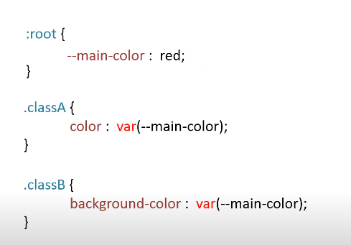

* Local Scope CSS Variables : it has limited-scope

